This publication, photographs, illustrations and software are under the protection of international copyright laws and all rights reserved. It does not allow any reproduction of this manual, content and any materials contained herein without the written consent of the authentic manufacturer.
The information in this manual is subject to change without notice. The manufacturer does neither represent nor warrant the contents hereof; and specifically disclaims any implied warranties of merchantability or fitness for any particular purpose. Furthermore, the manufacturer reserves the right to revise and change this publication from time to time, without the obligation of notifying any person of such revision or changes.

Trademarks
IBM, VGA, and PS/2 are registered trademarks of International Business Machines.|
Intel, Pentium, Pentium-II, and MMX are registered trademarks of Intel Corporation.
Microsoft, MS-DOS and Windows 95/98/NT/2000 are registered trademarks of Microsoft Corporation.
PC-cillin and ChipAwayVirus are trademarks of Trend Micro Inc.
AMI is a trademark of American Megatrends, Inc.
MediaRing Talk is a registered trademark of MediaRing Inc.
3Deep is a registered trademark of E-Color Inc.
It has been acknowledged that all mentioned brands or product names are trademarks or registered trademarks of their respective holders.

Copyright © 2001
All Rights Reserved
M900 Series, V1.0
I850/July 2001

Table of Contents
Chapter 1: Introduction 1
Key Features 2
Package Contents 5
Static Electricity Precautions 6
Pre-Installation Inspection 6
Chapter 2: Mainboard Installation 7
Mainboard Components 8
I/O Ports 9
Installing the Processor 9
Installing Memory Modules 11
Jumper Settings 12
Panel Connector 13
Other Devices Installation 14
Expansion Slots Installation 14
Connecting Optional Devices 16
Chapter 3: BIOS Setup Utility 19
Introduction 19
Running the SetupUtility .………………………. …..20
Standard CMOS Setup Page 21
Advanced Setup Page 22
Power Management Setup Page 24
PCI / Plug and Play Setup Page 26
Load Optimal Settings 27
Load Best Performance Settings 27
Features Setup Page 27
CPU PnP Setup Page 29
Hardware Monitor Page 30
Exit 30
Chapter 4: Software & Applications 31
Introduction 31
Installing Support Software 31
Auto-installing under Windows 98 33

Chapter 1

Introduction
Congratulations on purchasing the M900 mainboard. The M900 mainboard is an ATX mainboard that uses a 6-layer printed circuit board and measures 305 x 244mm. The mainboard features a Socket 423 that accommodates Intel Pentium 4 processors supporting front side bus (FSB) speeds up to 400 MHz and data bus bandwidths up to 3.2 GB/s.
The M900 incorporates the Intel Tehama 850 Northbridge and Intel 82801BA (ICH2) Southbridge chipsets, combining support for two-channel RAMBUS DRAM (RDRAM), 2X/4X AGP (1.5V only), and the AC 97 codec.
The Intel 82801I/O controller hub includes an integrated audio-codec controller that lets the processor efficiently decode sound generated by the integrated audio system.

Key Features
This mainboard has these key features:

Socket 423 Processor
- The PGA Socket 423
- Accommodates Intel Pentium 4 CPUs
- Supports a front-side bus (FSB) of 400 MHz
- Supports 3.2 GB/s data bus bandwidth

Chipset
Intel’s innovative Tehama 850 Northbridge and 82801 Southbridge chipsets are based on an innovative and scaleable architecture with proven reliability and performance. A few of the advanced features of the chipsets are:
- Host interface controller supports 400 MHz frontside (system) bus frequency
- Supports up to 2 GB of Rambus DRAM
- Supports a maximum memory bandwidth of 3.2 GB/s
- AGP controller is AGP 2.0 compliant and supports 2x/4x Fast Write Protocol (1.5V only)
- PCI IDE controller supports PCI bus mastering, PIO modes 0~4, and UDMA 33/66/100
- Two USB controllers double the bandwidth to 24 Mbps across four ports
- Integrated AC 97 audio that supports full surround sound with up to 2 channels
Additional key features include support for four USB ports, an AC 97 link for audio and modem, hardware monitoring, and ACPI/OnNow power management.
Memory Support
- The mainboard accommodates Rambus DRAM up to 2 GB using 2.5V unbuffered Rambus DRAM (RDRAM) memory modules.

VGA
- The M900 includes a 4xAGP slot that provides four times the bandwidth of the original AGP specification. AGP technology provides a direct connection between the graphics sub-system and the processor so that the graphics do not have to compete for processor time with other devices on the PCI bus.

AC 97 Audio Codec
- The AC 97 Audio codec is compliant with the AC 97 2.1 specification, and supports 18-bit ADC (Analog Digital Converter) and DAC (Digital Analog Converter) resolution as well as 18-bit stereo full-duplex codec with independent and variable sampling rates.

Expansion Options
The mainboard comes with the following expansion options:
- Five 32-bit PCI slots
- A 4xAGP slot (AGP Pro slot optional)
- A Communications Network Riser (CNR) slot
- Two IDE channels and a floppy disk drive interface
The M900 supports Ultra DMA bus mastering with transfer rates of 33/66/100 MB/sec.

Onboard I/O Ports
The mainboard has a full set of I/O ports and connectors:
- Two PS/2 ports for mouse and keyboard
- Two serial ports
- One parallel port
- One MIDI/game port
- Two USB ports
- Audio jacks for microphone, line-in and line-out

BIOS Firmware
This mainboard uses AMI BIOS that enables users to configure many system features including the following:
- Power management
- Wake-up alarms
- CPU parameters and memory timing
- CPU and memory timing
The firmware can also be used to set parameters for different processor clock speeds.

Bundled Software
- PC-Cillin 2000 provides automatic virus protection under Windows 95/98/NT/2000
- MediaRing Talk provides PC to PC or PC to Phone internet phone communication
- 3Deep delivers the precise imagery and displays accurate color in your monitor
- WinDVD2000 is a DVD playback application (optional)

Dimensions
- ATX form factor of 305 x 244 mm

Package Contents
Your mainboard package contains the following items:
- The mainboard
- The User’s Guide
- One diskette drive ribbon cable and bracket
- One IDE drive ribbon cable and bracket
- One auto-install software support CD
- Retention modules (already mounted on the board)
- Two CPU retention brackets
- Two dummy Rambus DRAM modules (already inserted in RIMM slots)

Optional Accessories
You can purchase the following optional accessories for this mainboard.
- Extended USB module
- CNR v.90 56K Fax/Modem card

Static Electricity Precautions
Components on this mainboard can be damaged by static electricity. Take the following precautions when unpacking the mainboard and installing it in a system.
1. Keep the mainboard and other components in their original static-
proof packaging until you are ready to install them.
2. During installation, wear a grounded wrist strap if possible. If you
don’t have a wrist strap, discharge static electricity by touching the
bare metal of the system chassis.
3. Handle the mainboard carefully by the edges. Avoid touching the
components unless it is absolutely necessary. During installation
put the mainboard on top of the static-protection packaging it came
in with the component side facing up.

Pre-Installation Inspection
Inspect the mainboard for damage to the components and
connectors on the board.
If you suspect that the mainboard has been damaged, do not
connect power to the system. Contact your mainboard vendor and
report the damage.

Chapter 2

Mainboard Installation
To install this mainboard in a system, follow the procedures in this chapter:
- Identify the mainboard components
- Install a CPU
- Install two or more system memory modules
- Verify that all jumpers or switches are set correctly
- Install the mainboard in a system chassis (case)
- Connect any extension brackets or cables to connecting headers on the mainboard
- Install other devices and make the appropriate connections to the mainboard connecting headers

Note:
1. Before installing this mainboard, make sure jumper JBAT1 is set to
Normal setting. See this chapter for information on locating JBAT1
and the setting options.
2. Never connect power to the system during installation. Doing so
may damage the mainboard.

Mainboard Components
Note: Any jumpers on your mainboard that do not appear in this illustration are for testing only.

I/O Ports
The backplane of the mainboard has a full set of I/O ports:

- Use the upper PS/2 port to connect a PS/2 pointing device. Use the lower PS/2 port to connect a PS/2 keyboard.
- Use the USB ports to connect USB devices.
- Use LPT1 to connect printers or other parallel communications devices.
- Use the COM ports to connect serial devices such as mice or fax/modems. COM1 is identified by the system as COM1/3. COM2 is identified by the system as COM2/4.
- Use the game port to connect a joystick or a MIDI device.
- Use the three audio ports to connect audio devices. The left side jack is for a stereo line-out signal. The middle jack is for a stereo line-in signal. The right side jack is for a microphone.

Installing the Processor
This mainboard has a Socket 423 processor socket. When choosing a processor, consider the performance requirements of the system. Performance is based on the processor design, the clock speed and system bus frequency of the processor, and the quantity of internal cache memory and external cache memory.

CPU Installation Procedure
The following illustration shows CPU installation components:
Follow these instructions to install the CPU:
- Pull the CPU socket locking lever away from the socket to unhook it and raise the locking lever to the upright position.
- Identify the pin-1 corner on the CPU socket and the pin-1 corner on the processor.
- Match the pin-1 corners and insert the processor into the socket. Do not use force.
- Swing the locking lever down and hook it under the latch on the edge of the socket.
- Apply thermal grease to the top of the CPU.
- Insert the CPU cooling fan/heatsink assembly.
- Plug the CPU fan cable connector into the CPU cooling fan power supply on the mainboard (CFAN).
- Insert the retention module clips over the edge of the CPU fan/heatsink assembly.

Installing Memory Modules
This mainboard accommodates 184-pin 2.5V unbuffered Rambus DRAM (RDRAM) memory modules. The memory chips must be standard or registered RDRAM. The memory bus runs at 400 MHz.

Installation Procedure
The mainboard has four RIMM (Rambus DIMM) slots that accommodate up to 2 GB of memory. You can only install the memory modules in pairs; therefore, you must install at least two RIMM modules. The dummy Rambus DRAM modules (C-RIMM) must be inserted in unpopulated slots.
- Align the memory module with the slot. The RIMM slots are keyed with notches and the RIMMs are keyed with cutouts so that they can only be installed correctly.
- Push the latches on each side of the RIMM slot down.
- Check that the cutouts on the RIMM module edge connector match the notches in the RIMM slot.
- Install the RIMM module into the slot and press it firmly down so that it seats correctly. The slot latches are levered upwards and latch on to the edges of the RIMM when it is installed correctly.
- Install any remaining RIMM modules.
- After installing your RIMM modules, insert the C-RIMM modules in the unoccupied slots:

Jumper Settings
Jumper JBAT1 – enables you to clear the BIOS:
1. Turn the system off.
2. Remove all ATX power connectors.
3.Short pins 2 and 3 on JBAT1.
4.Return the jumper to the normal setting.
5.Plug in all ATX power connectors
6.Turn the system on. The BIOS is returned to the default settings.
Jumper | Type | Description | Setting (default)
JBAT1 | 3 pin | Clear CMOS | 1-2: Normal  2-3: Clear

Jumper 1 & Jumper 2 – enable this jumper if you want keyboard
activity to turn on the computer.
Jumper | Type | Description | Setting (default)
JP1 &  JP2 | 3 pin  3 pin | Keyboard power on | 1-2: Enable  2-3: Disable

Jumper 12 – This jumper enables or disables the onboard audio
codec.
Jumper | Type | Description | Setting (default)
JP12 | 3 pin | Enable onboard audio codec | 1-2: Enable  2-3: Disable

The Panel Connector
The panel connector provides a standard set of switch and LED connectors usually found on ATX or micro-ATX cases. Refer to the table below for information:
Device | Pins
Empty | 10
N/C | 9
Power ON/OFF | 6, 8
Reset Switch | 5, 7
Green LED  Indicator | +2, -4
HDD LED | +1, -3

Other Devices Installation

Floppy Diskette Drive Installation
The mainboard has a floppy diskette drive (FDD) interface ships with a diskette drive ribbon cable that supports one or two floppy diskette drives. You can install a 5.25-inch drive and a 3.5-inch drive with various capacities. The floppy diskette drive cable has one type of connector for a 5.25-inch drive and another type of connector for a 3.5-inch drive.

IDE Devices
Your mainboard has a primary and secondary IDE channel interface (IDE1 and IDE2). An IDE ribbon cable supporting two IDE devices is bundled with the mainboard. IDE devices have jumpers or switches that are used to set the IDE device as MASTER or SLAVE. Refer to the IDE device user’s manual.
If you want to install more than two IDE devices, get a second IDE cable and you can add two more devices to the secondary IDE channel.
When installing two IDE devices on one cable, ensure that one device is set to MASTER and the other device is set to SLAVE.
This mainboard supports UltraDMA 33/66/100. UDMA is a technology that accelerates the performance of devices in the IDE channel. Install IDE devices that support UDMA and use IDE cables that support UDMA for better performance.

Expansion Slots Installation
This mainboard has five 32-bit PCI (Peripheral Components Interconnect) expansion slots, one 4xAGP slot, and one Communications and Networking Riser (CNR) slot.

PCI Slots
PCI slots are used to install expansion cards that have the
32-bit PCI interface.

4 x AGP Slot
The 4xAGP slot is used to install a graphics adapter that supports the 4xAGP specification and has a 4xAGP edge connector. The 4xAGP slot only supports 1.5V 4xAGP and 2xAGP cards.

CNR Slot
This slot is used to insert CNR cards including LAN, Modem, and Audio functions.
CNR1

PCI1 PCI2 PCI3 PCI4 PCI5
AGP

- Remove a blanking plate from the system case corresponding to the slot you are going to use.
- Install the edge connector of the add-on card into the expansion slot. Ensure that the edge connector is correctly seated in the slot.
- Secure the metal bracket of the card to the system case with a screw.

Connecting Optional Devices

WOL1/WOM1: Wake On LAN/Wake On Modem
If you have installed a LAN card, use the cable provided with the card to plug into the mainboard WOL1 connector. This enables the Wake On LAN (WOL) feature. When your system is in a power-saving mode, any LAN signal automatically resumes the system. You must enable this item using the Power Management page of the Setup Utility.
Pin | Signal Name
1  2  3 | 5VSB  Ground  SENSE
If you have installed a modem, use the cable provided with the modem to plug into the mainboard WOM1 connector. This enables the Wake On Modem (WOM) feature.
When your system is in a power-saving mode, any modem signal automatically resumes the system. You must enable this item using the Power Management page of the Setup Utility. See Chapter 3 for more information.

USB2: USB port 3, 4
The mainboard has two USB ports installed on the rear edge I/O port array. However, some computer cases have a special module that mounts USB ports at the front of the case. If you have this kind of case, use auxiliary USB connectors USB2 and USB3 to connect the front-mounted ports to the mainboard.
Pin | Signal Name | Pin | Signal Name
1  3  5  7  9 | Port 3 power  Port 3 USB-  Port 3 USB+  Port 3 ground  Protection key | 2  4  6  8  10 | Port 4 power  Port 4 USB-  Port 4 USB+  Port 4 ground  Over current sensor

JIR1: Consumer infrared port
The mainboard supports a Consumer Infrared (CIR) data port. Infrared ports allow the wireless exchange of information between your computer and similarly equipped devices such as printers, laptops, Personal Digital Assistants (PDAs), and other computers.
Pin | Signal Name | Pin | Signal Name
1  3  5 | CIR receive  +5V  IR transmit | 2  4  6 | KEY  Ground  IR receiver

Chapter 3

BIOS Setup Utility

Introduction
The BIOS Setup Utility records settings and information about your computer such as the date and time, the kind of hardware installed, and various configuration settings. Your computer uses this information to initialize all the components when booting up and functions as the basis for coordination between system components.

If the Setup Utility configuration is incorrect, it may cause the system to malfunction. It can even stop your computer from booting properly. If this happens, you can use the clear CMOS jumper to clear the CMOS memory used to store the configuration information.

You can run the setup utility and manually make changes to the configuration. You might need to do this to configure some of the hardware that you install on or connect to the mainboard, such as the CPU, system memory, disk drives, etc.

Running the Setup Utility
Each time your computer starts, before the operating system loads, a message appears on the screen that prompts you to “Hit <DEL> if you want to run SETUP”. When you see this message, press the Delete key and the Main menu page of the Setup Utility appears on your monitor.
AMIBIOS SIMPLE SETUP UTILITY – VERSION 1.21.05
(C) 2000 American Megatrends, Inc. All Rights Reserved
Standard CMOS Setup  Advanced Setup  Power Management Setup  PCI / Plug and Play Setup  Load Optimal Settings  Load Best Performance Settings | Features Setup  CPU PnP Setup  Hardware Monitor  Change Password  Exit
Esc : Quit ↑ ↓ ← →: Select Item (Shift)F2 : Change Color F5 : Old Values
F6 : Optimal values F7 : Best performance values F10 : Save&Exit
Standards COMOS setup for changing time, date, hard disk type, etc.
You can use the cursor arrow keys to highlight any of the options on the main menu page. Press Enter to select the highlighted option. To leave the setup utility, press the Escape key. To cycle through the Setup Utility’s optional color schemes hold down the Shift key and press F2.
Some of the options on the main menu page lead to tables of items with installed values. In these pages, use the cursor arrow keys to highlight the items, and then use the PgUp and PgDn keys to cycle through the alternate values for each of the items. Other options on the main menu page lead to dialog boxes which require you to answer Yes or No by hitting the Y or N keys.
If you have already made changes to the setup utility, press F10 to save those changes and exit the utility. Press F5 to reset the changes to the original values. Press F6 to install the setup utility with a set of default values. Press F7 to install the setup utility with a set of high-performance values.

Standard CMOS Setup Page
This option displays a table of items defining basic information about your system.
AMIBIOS SETUP – STANDARD CMOS SETUP
(C) 2000 American Megatrends, Inc. All Rights Reserved
Date (mm/dd/yy) : Tue Oct 24, 2000
Time (hh/mm/ss) : 14:26:53
LBA Blk PIO 32Bit
Type Size Cyln Head WPcom Sec Mode Mode Mode Mode
Pri Master : Auto off
Pri Slave : Auto off
Sec Master : Auto off
Sec Slave : Auto off
Floppy Drive A : 1.44 MB 3 1/2”
Floppy Drive B : Not Installed
Month : Jan – Dec ESC : Exit
Day : 01 – 31 ↑↓ : Select Item
Year : 1901 – 2099 PU/PD/+/- : Modify
(Shift)F2 : Color
F3 : Detect All HDD

Date & Time | Use these items to set up system date and time
Pri Master  Pri Slave  Sec Master  Sec Slave | Use these items to configure devices connected to the Primary and Secondary IDE channels. To configure an IDE hard disk drive, choose Auto. If the Auto setting fails to find a hard disk drive, set it to User, and then fill in the hard disk characteristics (Size, Cyls, etc.) manually. If you have a CD-ROM drive, select the setting CDROM. If you have an ATAPI device with removable media (e.g. a ZIP drive or an LS-120), select Floptical.
Floppy Drive A  Floppy Drive B | Use these items to set up size and capacity of the floppy diskette drive(s) installed in the system.

Advanced Setup Page
This option displays a table of items that define advanced information about your system.
AMIBIOS SETUP – ADVANCED SETUP
(C) 2000 American Megatrends, Inc. All Rights Reserved
Quick Boot Enabled
1st Boot Device IDE-0
2nd Boot Device Floppy
3rd Boot Device CDROM
Try Other Boot Devices Yes
S.M.A.R.T. for Hard Disks Disabled
BootUp Num-Lock On
Floppy Drive Swap Disabled
Floppy Drive Seek Disabled
Password Check Setup
Boot To OS/2 > 64MB No
L1 Cache Enabled
L2 Cache Enabled
Cache Bus ECC Disabled
System BIOS Cacheable Enabled
Video BIOS Cacheable Disabled
Auto detect PCI Clock Disabled
CLK Spread Spectrum Disabled
ESC : Quit ↑↓←→ : Select Item
F1 : Help PU/PD/+/- : Modify
F5 : Old Values (Shift)F2 : Color
F6 : Load BIOS Defaults
F7 : Load Setup Defaults

Quick Boot | If you enable this item, the system starts up more quickly be elimination some of the power on test routines.
1st Boot Device  2nd Boot Device  3rd Boot Device | Use these items to determine the device order the computer uses to look for an operating system to load at start-up time.
Try Other Boot Device | If you enable this item, the system will also search for other boot devices if it fails to find an operating system from the first two locations.
S.M.A.R.T. for Hard Disks | Enable this item if any IDE hard disks support the S.M.A.R.T. (Self-Monitoring, Analysis and Reporting Technology) feature.
BootUp Num-Lock | This item determines if the Num Lock key is active or inactive at system start-up time.
Floppy Drive Swap | If you have two diskette drives installed and you enable this item, drive A becomes drive B and drive B becomes drive A.
Floppy Drive Seek | If you enable this item, your system will check all floppy disk drives at start up. Disable this item unless you are using an old 360KB drive.
Password Check | If you have entered a password for the system, use this item to determine, if the password is required to enter the Setup Utility (Setup) or required both at start-up and to enter the Setup Utility (Always).
Boot to OS/2 > 64MB | Enable this item if you are booting the OS/2 operating system and you have more than 64MB of system memory installed.
L1/L2 Cache | Leave these items enabled since all the processors that can be installed on this board have internal L1/L2 cache memory.
Cache Bus ECC | This item can perform the error check correction function.
System BIOS Cacheable | If you enable this item, a segment of the system BIOS will be cached to main memory for faster execution.
Video BIOS Cacheable | If you enable this item, a segment of the system BIOS will be cached to main memory for faster execution.
Auto detect PCI Clock | When this item is enabled, BIOS will disable the clock signal of free PCI slots.
CLK Spread Spectrum | Use this item to set the system bus spread spectrum for the installed processor.

Power Management Setup Page
This page sets some of the parameters for system power management operation.
AMIBIOS SETUP – POWER MANAGEMENT SETUP
(C) 2000 American Megatrends, Inc. All Rights Reserved
Power Management/APM Enabled
ACPI Aware O/S Yes
Standby Time Out Disabled
Suspend Time Out Disabled
Wake Up on Ring Disabled
Wake Up on LAN Disabled
Wake Up on PME Disabled
K/B Power-on function Disabled
Stroke keys selected N/A
Resume by Alarm Disabled
RTC Alarm Date 15
RTC Alarm Hour 12
RTC Alarm Minute 30
RTC Alarm Second 30
ESC : Quit ↑↓←→ : Select Item
F1 : Help PU/PD/+/- : Modify
F5 : Old Values (Shift)F2 : Color
F6 : Load BIOS Defaults
F7 : Load Setup Defaults

Power Management | Use this item to enable or disable a power management scheme. If you enable power management, you can use the items below to set the power management operation. Both APM and ACPI are supported.
ACPI Aware O/S | This item supports ACPI (Advanced Configuration and Power management Interface). Use this item to enable or disable the ACPI feature.
Standby Time Out | This sets the timeout for Standby mode in minutes. If the time selected passes without any system activity, the computer will enter power-saving Standby mode.
Suspend Time Out | This sets the timeout for Suspend mode in minutes. If the time selected passes without any system activity, the computer will enter power-saving Suspend mode.
Wake Up on Ring | The system can be turned off with a software command. If you enable this item, the system can automatically resume if there is an incoming call on the Fax/Modem. You must use an ATX power supply in order to use this feature.
Wake Up on LAN | The system can be turned off with a software command. If you enable this item, the system can automatically resume if there is an incoming call on the Fax/Modem. You must use an ATX power supply in order to use this feature.
Wake Up on PME# | The system can be turned off with a software command. If you enable this item, the system can automatically resume if there is an incoming call on the Fax/Modem. You must use an ATX power supply in order to use this feature. Use this item to do wake-up action if inserting the PCI card.
Keyboard Power On Function | If you enable this item, you can turn the system on and off by pressing hot keys on the keyboard. You must enable the Keyboard Power On jumper and use an ATX power supply in order to use this feature.
Resume By Alarm | The system can be turned off with a software command. If you enable this item, the system can automatically resume if there is an incoming call on the Fax/Modem. You must use an ATX power supply in order to use this feature.
RTC Alarm / Date / Hour / Minute / Second | The system can be turned off with a software command. If you enable this item, the system can automatically resume at a fixed time based on the system’s RTC (realtime clock). Use the items below this one to set the date and time of the wake-up alarm. You must use an ATX power supply in order to use this feature.

PCI / Plug and Play Setup Page
This page sets some of the parameters for devices installed on the PCI bus and devices that use the system plug and play capability.
AMIBIOS SETUP – PCI / PLUG AND PLAY SETUP
(C) 2000 American Megatrends, Inc. All Rights Reserved
Plug and Play Aware O/S Yes
Primary Graphics Adapter PCI
Allocate IRQ for PCI VGA Yes
VGA Frame Buffer USWC Disabled
PCI Frame Buffer USWC Disabled
Graphics Aperture Size 64 MB
ESC : Quit ↑↓←→ : Select Item
F1 : Help PU/PD/+/- : Modify
F5 : Old Values (Shift)F2 : Color
F6 : Load BIOS Defaults
F7 : Load Setup Defaults

Plug and Play Aware O/S | Enable this item if you are using an O/S that supports Plug and Play such as Windows 95 or 98.
Primary Graphics Adapter | This item indicates if the primary graphics adapter uses the PCI or the AGP bus. The default PCI setting still lets the onboard display work and allows the use of a second display card installed in a PCI slot.
Allocate IRQ for PCI VGA | If this item is enabled, an IRQ will be assigned to the PCI VGA graphics system. You set this value to No to free up an IRQ.
VGA Frame Buffer USWC | These item sets the VGA frame buffer for USWC. USWC (Uncacheable, Speculative Write Combining) is a cache memory technology. Leave these items at the default value.
PCI Frame Buffer USWC | These item sets the PCI frame buffer for USWC. USWC (Uncacheable, Speculative Write Combining) is a cache memory technology. Leave these items at the default value.
Graphics Aperture Size | This item defines an AGP for the graphics. Leave this item at the default value 64MB.

Load Optimal Settings
If you select this item and press Enter a dialog box appears. If you press Y, and then Enter, the Setup Utility loads a set of fail-safe default values. These default values are not very demanding and they should allow your system to function with most kinds of hardware and memory chips.

Load Best Performance Settings
If you select this item and press Enter a dialog box appears. If you press Y, and then Enter, the Setup Utility loads a set of best-performance default values. These default values are quite demanding and your system might not function properly if you are using slower memory chips or other low-performance components.

Features Setup Page
This page sets some of the parameters for peripheral devices connected to the system.
AMIBIOS SETUP – FEATURES SETUP
(C) 2000 American Megatrends, Inc. All Rights Reserved
OnBoard FDC Enabled
OnBoard Serial Port1 3F8/COM1
OnBoard Serial Port2 2F8/COM2
Serial Port2 Mode Normal
OnBoard Parallel Port 378
Parallel Port Mode Normal
Parallel Port IRQ 7
Parallel Port DMA Channel N/A
AC97 Audio Controller Auto
AC97 Modem Controller Auto
OnBoard MIDI Port 330
MIDI Port IRQ 10
OnBoard Game Port 200
USB Function Enabled
USB Function for DOS Disabled
ESC : Quit ↑↓←→ : Select Item
F1 : Help PU/PD/+/- : Modify
F5 : Old Values (Shift)F2 : Color
F6 : Load BIOS Defaults
F7 : Load Setup Defaults

OnBoard FDC | Use this item to enable or disable the onboard floppy disk drive interface.
OnBoard Serial Port1/2 | Use these items to enable or disable the onboard COM1/2 serial port, and to assign a port address.
Onboard Parallel Port | Use this item to enable or disable the onboard LPT1 parallel port, and to assign a port address. The Auto setting will detect and available address.
Parallel Port Mode | Use this item to set the parallel port mode. You can select SPP (Standard Parallel Port), ECP (Extended Capabilities Port), EPP (Enhanced Parallel Port), or ECP + EPP.
Parallel Port DMA | Use this item to assign a DMA channel to the parallel port.
Onboard IDE | Use this item to enable or disable either or both of the onboard Primary and Secondary IDE channels.
Parallel Port IRQ | Use this item to assign IRQ to the parallel port.
AC’97 Audio Controller | This item enables or disables the AC’97 audio chip.
AC’97 Modem Controller | This item enables or disables the AC’97 modem chip.
OnBoard MIDI Port | Use this item to enable or disable the onboard MIDI port, and to assign a port address.
MIDI Port IRQ | Use this item to assign IRQ 7 to the parallel port.
OnBoard Game Port | This item enables or disables the I/O address for the game port.
USB Function | Use this item to select the USB ports or disabled.
USB Function for DOS | Enable this item if you plan to use the USB ports on this mainboard in a DOS environment.

CPU PnP Setup Page
This page helps you manually configure the mainboard for the CPU. The system will automatically detect the type of installed CPU and make the appropriate adjustments to the items on this page.
AMIBIOS SETUP – CPU PnP SETUP
©2000 American Megatrends, Inc. All Rights Reserved
CPU BRAND INTEL
CPU Type Pentium 4
CPU Speed 1.7 GHz
CPU Ratio 17.0x
CPU Frequency 100 MHz
CPU VCORE +1.680V
ESC : Quit ↑↓←→ : Select Item
F1 : Help PU/PD/+/- : Modify
F5 : Old Values (Shift)F2 : Color
F6 : Load Optimal values
F7 : Load Best performance values

CPU BRAND/Type/ Core Voltage/Ratio /Frequency | These items show the type, core voltage, ratio and frequency of CPU installed in your system.
CPU Speed | This item decides CPU speed installed in your system.

Hardware Monitor Page
This page sets some of the parameters for the hardware monitoring function of this mainboard.
AMIBIOS SETUP – HARDWARE MONITOR
(C) 2000 American Megatrends, Inc. All Rights Reserved
*** Hardware Monitor ***
System Temperature 38°C/100°F
CPU Temperature 58°C/138°F
System Fan Speed 0 RPM
Power Fan Speed 0 RPM
CPU Fan Speed 4655 RPM
VBAT + 3,392V
+ 3,300V + 3,328V
+ 5.000V VCC + 4,976V
-- 5,000V -- 5,292V
--12,000V --11,890V
+ 12,000V +11,856V

ESC : Quit ↑↓←→ : Select Item
F1 : Help PU/PD/+/- : Modify
F5 : Old Values (Shift)F2 : Color
F6 : Load BIOS Defaults
F7 : Load Setup Defaults

CPU / System Temperature | These items display CPU and system temperature measurement.
FANs & Voltage Measurements | These items indicate cooling fan speeds in RPM and the various system voltage measurements.

Exit
Highlight this item and press Enter to save the changes that you have made in the Setup Utility configuration and exit the program. When the Save and Exit dialog box appears, press Y to save and exit, or press N to exit without saving.

Chapter 4

Software & Applications

Introduction
The support software CD-ROM that is included in the mainboard package contains all the drivers and utility programs needed to properly run our products. Below you can find a brief description of each software program, and the location for your mainboard version. More information on some programs is available in a README file, located in the same directory as the software.
If the operating system used in your system is Windows 98, it will automatically install all the drivers and utilities for your board. See the Auto-Installing under Windows 98 section.

Installing Support Software
The software on the support CD-ROM is for Windows 95/NT/2000 and Windows 98. The installation procedure differs depending on which Operating System you have, but the automatic installation is now for Win98 only.

Installing under Windows 95/NT/2000
To install support software for Windows 95/NT/2000 follow this general procedure:
1. Insert the support CD-ROM disc in the CD-ROM drive.
(The system might get an error message from the PnP function. Don’t care the message. You don’t really need that file to install the drivers)
2. Use My Computer or Windows Explorer to look at the directory
structure. You must use the Open command in the right-button menu. Double-clicking on the drive icon will result in an error message because the disc’s AutoRun feature doesn’t work in Windows 95/NT/2000.
3. Execute the EXE file name given in the description below.
Note: The correct path name for each software driver is provided,
where D: identifies the CD-ROM drive letter – modify if necessary.

Bus Master IDE Driver
The IDE Bus Master Drivers allows the system to properly manage the IDE channels on the mainboard. You need to install two drivers if you are running Windows 9x.
- Windows 9x – D:\IDE\INTEL850

USB Driver
The USB Driver allows the system to recognize the USB ports on the mainboard. You need to install this driver if you are running Windows 95. Windows 95 OSR2 does not require this driver.
This driver is available for:
- Win95 – D:\USB\EUSBSUPP\USBSUPP.EXE
- Win95 (Chinese) – D:\USB\CUSBSUPP\CUSBSUPP.EXE

3Deep Software
Find the software here:
♦ D:\3Deep\3Deep 3.3\Setup.EXE

Sound Driver
Find the software here:
♦ D:\Sound\Driver\ALC200

BIOS Update Utility
The BIOS Update utility allows you to update the BIOS file on the mainboard to a newer version. You can download the latest version of the BIOS setup available for your mainboard from the website.
♦ D:\UTILITY\AMINFXXX.EXE

PC-Cillin Software
The PC-cillin software program provides anti-virus protection for your system.
This program is available for:
♦ Win9x – D:\PC-CILLIN\

Auto-installing under Windows 98
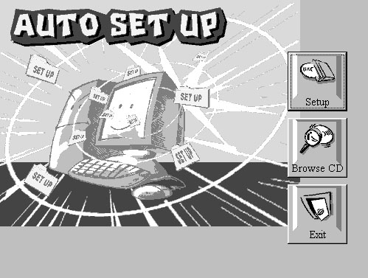
The support software CD-ROM disc loads automatically under Windows 98. When you insert the CD-ROM disc in the system CD-ROM drive the Autorun feature will automatically bring up the install screen. The screen has three buttons on it, Setup, Browse CD and Exit. See the following screen illustration.
When you click on the Setup button the software installation program will run and you can select what kind of installation you want to do, as explained later in this section.
The Browse CD button is the standard Windows command that allows you to examine the contents of the disc using the Windows 98 file browsing interface.
The Exit button closes the Auto Setup window. To run the program again, reinsert the CD-ROM disc in the drive or click on AutoRun in the context sensitive menu for the CD-ROM drive icon in a file browser window.
Installing Software with Auto Setup
To install support software for the system board follow this procedure:
- Click on the Setup button. The install program will load
and display the following screen. Click the Next button.
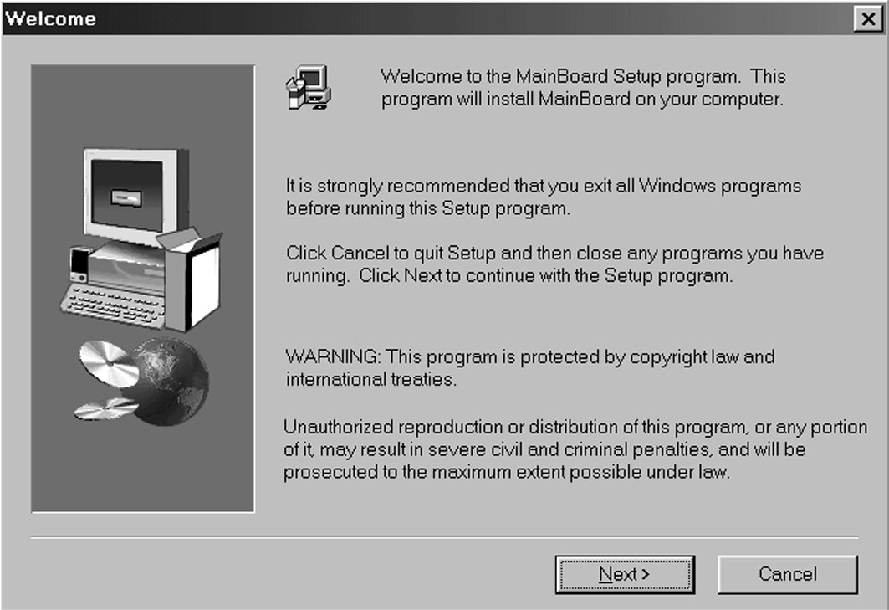
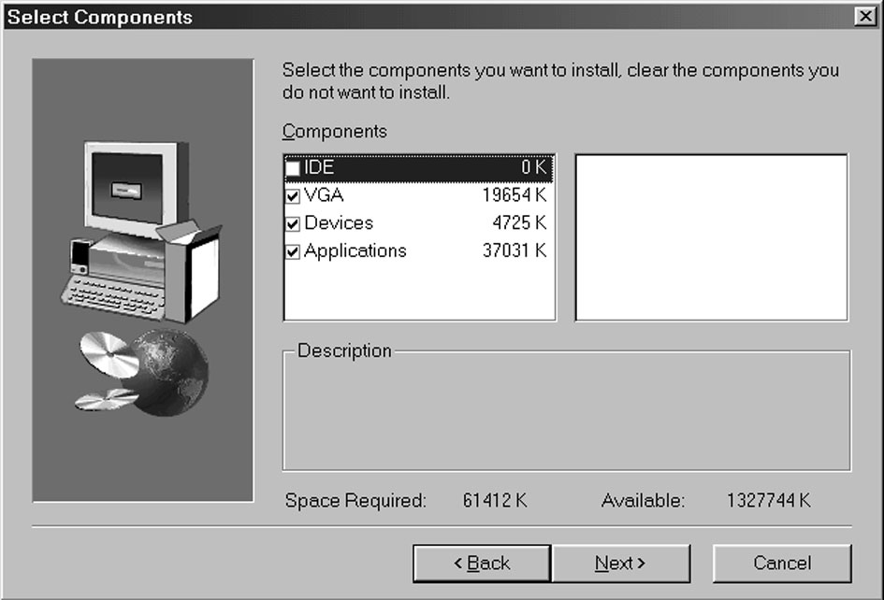
2. Select the items that you want to setup by clicking on it
(the default options are recommended). Click the Next
button to proceed.

- The support software will automatically install.
Once any of the installation procedures start, software is automatically installed in sequence. You will need to follow the onscreen instructions, confirm commands and allow the computer to restart as few times as is needed to complete installing whatever software you selected to install. When the process is finished, all the support software will be installed and working.
There are some utilities that you have to manually install if you need, check to the above section.

